©The Board

The Timetabling and Examinations Department



**Group 2**

**Members Registration Number**

1. Charles Brian Bett S13/11753/15

2. Frankline Apiyo S13/09724/15

3. Brian Kemboi S13/09694/15

4. Solomon Kogie S13/09696/15

5. Edwin Mwaura S13/09675/15

Contents

1 Definitions - 3 -

2 Introduction - 4 -

3 System Request - 5 -

4 Feasibility Analysis - 6 -

4.1 Technical feasibility. - 6 -

4.2 Economic feasibility. - 6 -

5 WORK BREAKDOWN STRUCTURE - 8 -

6 WORKPLAN - 9 -

7 Functional and Non-functional Requirements - 11 -

7.1 Functional Requirements - 11 -

7.1.1 Enter Data - 11 -

7.1.2 Make Timetable - 11 -

7.1.3 Manage Timetable - 11 -

7.1.4 Deliver Timetable - 11 -

7.2 Non- functional Requirements - 12 -

7.2.1 Operational Requirements - 12 -

7.2.2 Performance Requirements - 12 -

7.2.3 Security Requirement - 12 -

7.2.4 Cultural & Political Requirement - 12 -

8 USE CASE DAIGRAM - 13 -

9 ACTIVITY DIAGRAMS - 14 -

10 CRC CARDS - 17 -

11 USE CASE DESCRIPTIONS - 22 -

12 CLASS DIAGRAM: - 25 -

13 SEQUENCE DIAGRAMS: - 26 -

14 COMMUNICATION DIAGRAMS: - 29 -

15 CRUDE MATRIX: - 32 -

16 PACKAGE DIAGRAM: - 33 -

17 Method Design - 34 -

18 User Interface - 36 -

# Definitions

**Use case** – describes a goal-oriented interaction between the system and an actor. A use case may define several variants called scenarios that result in different paths through the use case and usually different outcomes.

**Scenario** – one path through a use case

**Actor** – user or other software system that receives value from a use case.

**Role** – category of users that share similar characteristics.

**Product** – what is being described here; the software system specified in this document.

**Project** – activities that will lead to the production of the product described here. Project issues are described in a separate project plan.

**Shall** – adverb used to indicate importance; indicates the requirement is mandatory. “Must” and “will” are synonyms for “shall”.

**Should** – adverb used to indicate importance; indicates the requirement is desired but not mandatory.

**May** – adverb used to indicate an option. For example, “The system may be taken offline for up to one hour every evening for maintenance.” Not used to express a requirement, but rather to specifically allow an option.

**Controls** – the individual elements of a user interface such as buttons and check boxes.

**I.E.O** – Internal Examinations Officer.

# Introduction

We will be looking solely at the timetable making process. All processes in the timetabling department are manual. The timetable making process starts two months before the semester starts. The Internal Examinations Officer in every department provides information crucial to the timetable making process

This information includes:

* + 1. The unit code and title
    2. The number of students taking it
    3. The CF of the unit
    4. Special requirements
    5. Number of groups

The timetable is posted a week before the semester starts. It is sent to Internal Examinations Officers, Lecturers and Posted on the noticeboards in the school. It is also sent to the ICT dept. so that it can be published in the portal. If there are any conflicts lecturers and class reps consult the timetable department within the first two weeks. The Room-Chart (Paper the **TEACHING timetable** is written on) is used to allocate and reallocate class venues and time. Apart from the teaching timetable they also make the following timetables:

* + 1. Exam Timetable
    2. School Calendar
    3. Trip Schedule
    4. Allocating rooms for Functions e.g. Church, Seminars, etc.

# System Request

**Project Name:** Timetabling Project

**Project Sponsor:** Dr Perminus Karubiu Migwi

Name:

Department: Timetabling and examinations department

Organization: Egerton University

Phone: +254-722 178 054 E-mail: [pemigwi@yahoo.com](mailto:pemigwi@yahoo.com)

**Business Need:**

To decrease the cost and increase the efficiency of creating and managing teaching timetables.

**Business Requirements:**

The system shall generate time table automatically.

The system shall manage units and venue scheduling.

The system should post time table to the portal.

# Feasibility Analysis

## Technical feasibility.

1. Familiarity with the functional area.

The project team is fairly familiar with the functional area of the project. The users of the system have a high familiarity with the functional area of the project. The technical risk is therefore very low.

1. Familiarity with the technology.

The project team is highly familiar with the java programming language, the central technology in the implementation of the project. This also further lowers the technical risk in developing the system.

1. Size of the project.

a) Duration: 4 months

b) Size of project team: 5 members.

c) The number of distinct features in the system: 6

These metrics for the project size indicates an average amount of complexity.

## Economic feasibility.

|  |  |
| --- | --- |
| **Development cost** | **Operational cost** |
|  | Licencing fees  Operation staff. |
| **Tangible benefits** | **Intangible benefits** |
| Reduction in staff.  Reduction in inventory. | Faster time table generation. |

|  |
| --- |
| **Benefits:**  Reduction in staff: KSH 420000  Reduction in inventroy: KSH 3000  **Total benefits:** KSH 423000  **Development costs:** KSH 0  **Operational costs:**  Licencing fees: KSH 50000  Operation staff KSH 120000  **Total Operational costs:**  KSH 425000  **Total cost:** KSH 425000 |

|  |  |  |  |
| --- | --- | --- | --- |
|  | 2018 | 2019 | 2020 |
| Reduction in staff | 420,000 | 420,000 | 420,000 |
| Reduction in inventory | 3,000 | 3,000 | 3,000 |
| Total benefits | 423,000 | 423,000 | 423,000 |
| PV Of Benefits | 423,000 | 456,156.15 | 491,911.19 |
| PV Of All Benefits | 423,000 | 912,312.3 | 1,404,223.49 |
| Costs |  |  |  |
| Licencing Fees | 5,000 | 5,000 | 5,000 |
| Operational staff | 120,000 | 120,000 | 120,000 |
| Total cost: | 125,000 | 125,000 | 125,000 |
| PV Of Costs | 125,000 | 134,797.92 | 145,363.83 |
| PV Of All Costs | 125,000 | 259,797.92 | 405,161.75 |
| Yerly NPV | 298,000 | 312,358.23 | 346,547.36 |
| Cumulative NPV | 298,000 | 610,358.23 | 956,905.59 |
| Return On Ivestment | 447,317.19 / 1,404,223.49 | 31.86 % |  |

# WORK BREAKDOWN STRUCTURE

**I. Business Modelling**

a. Inception

b. Elaboration

c. Construction

d. Transition

e. Production

**II. Requirements**

a. Inception

b. Elaboration

c. Construction

d. Transition

e. Production

**III. Analysis**

a. Inception

b. Elaboration

c. Construction

d. Transition

e. Production

**IV. Design**

a. Inception

b. Elaboration

c. Construction

d. Transition

e. Production

# WORKPLAN

|  |  |  |
| --- | --- | --- |
| **Activity** | **Duration** | **Dependency** |
| 1. **Business Modelling** 2. Inception 3. Understand current business situation 4. Uncover business process problems 5. Identify potential projects 6. Elaboration 7. Construction 8. Transition 9. Production | 0.25 days  0.25 days  0.25 days |  |
| 1. **Requirements** 2. **Inception** 3. Identify appropriate requirements-gathering technique 4. Identify appropriate requirements-analysis technique 5. Identify functional and non-functional requirements 6. Conduct interviews 7. Interview timetabling staff 8. Observe timetabling process 9. Analyze current systems 10. Create requirements definition 11. Determine requirements to track 12. Review requirements with timetabling staff 13. Elaboration 14. Construction 15. Transition 16. Production | 1 day  1 day  0.5 days  1 day  1 day  1 day  0.25 days  0.25 days | **II.a.1, II.a.2**  **II.a.1, II.a.2**  **II.a.3**  **II.a.5.A** |
| 1. **Analysis** 2. Inception 3. Identify business processes 4. Identify use cases 5. Elaboration 6. Construction 7. Transition 8. Production | 2 days  3 days | **III.a.1** |
| 1. **Design** 2. Inception 3. Identify potential classes 4. Elaboration 5. Construction 6. Transition 7. Production | 5 days | **III.a** |

# Functional and Non-functional Requirements

## Functional Requirements

The following were our functional requirements:

* Enter Data
* Make Timetable
* Manage Timetable
* Deliver Timetable

### Enter Data

Internal Examinations Officer enters data:

1. Unit name
2. Unit code
3. No of students
4. No of disabled students /lecturers
5. No of groups
6. CFs
7. Special remarks

### Make Timetable

System will:

1. Venue allocation – student no
2. Allocate time – CFs
3. Time scope specification
4. Display available rooms and capacity
5. Switch venues to cater for special conditions

### Manage Timetable

1. Search unit courses, time, venues
2. Alter the auto-generated timetable
3. Share the timetable

### Deliver Timetable

1. Post timetable to portal
2. Send copies to students and lecturers and CODs

## Non- functional Requirements

The following were our non-functional requirements:

* Operational Requirement
* Performance Requirement
* Security Requirement
* Cultural & Political Requirement

### Operational Requirements

1. System will run on jvm
2. System should print the timetable – per faculty & department
3. Back up timetable after any changes
4. Only accept fully filled forms
5. System should be connected only to the organizations network

### Performance Requirements

1. System should generate timetable within 5 seconds
2. Retrieval and alterations should be done within 5 seconds
3. Sending of timetables should be done within 10 seconds

### Security Requirement

1. Only Internal Examinations Officer should send data
2. Only administrator can generate and alter timetable
3. Only specified persons should receive timetable

### Cultural & Political Requirement

No special cultural and political requirements are anticipated

# USE CASE DAIGRAM

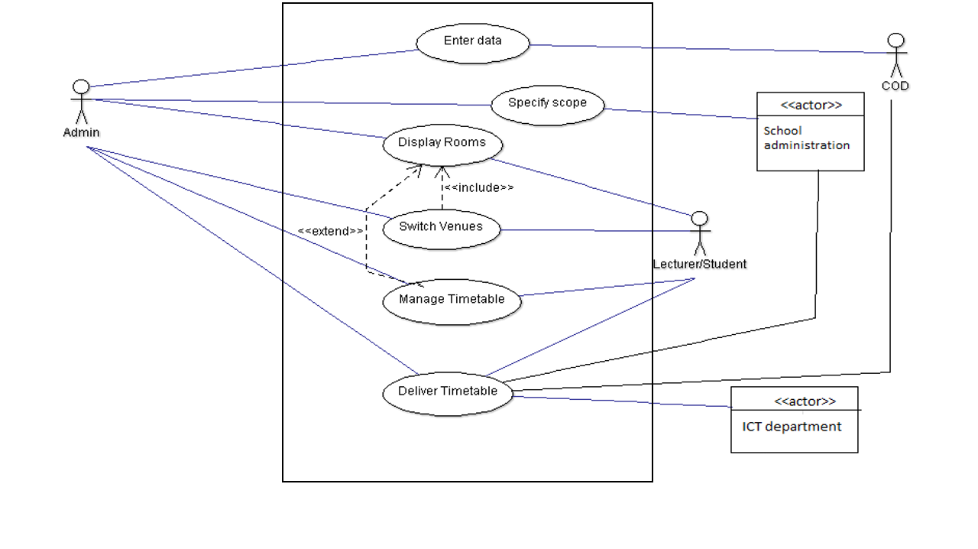

# ACTIVITY DIAGRAMS

Activity diagram 1.

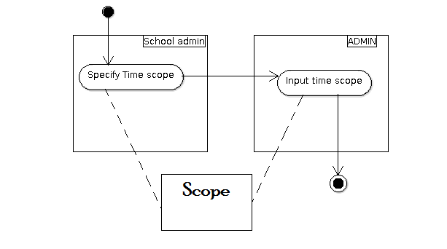Activity diagram 2.

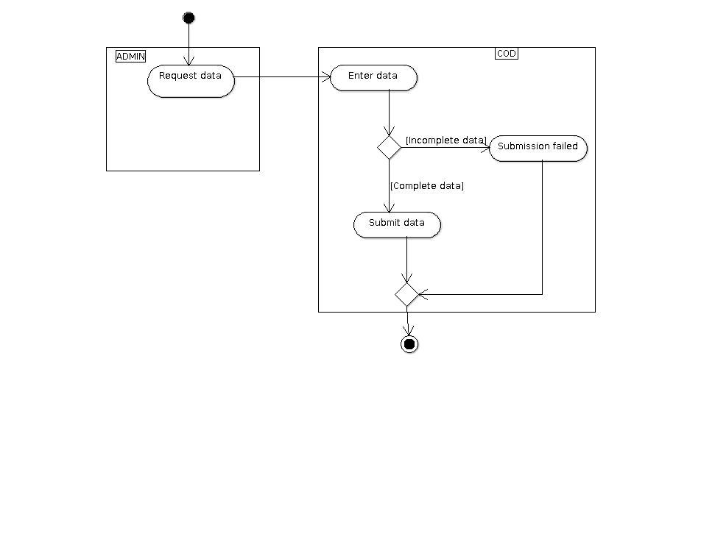

Activity diagram 3. 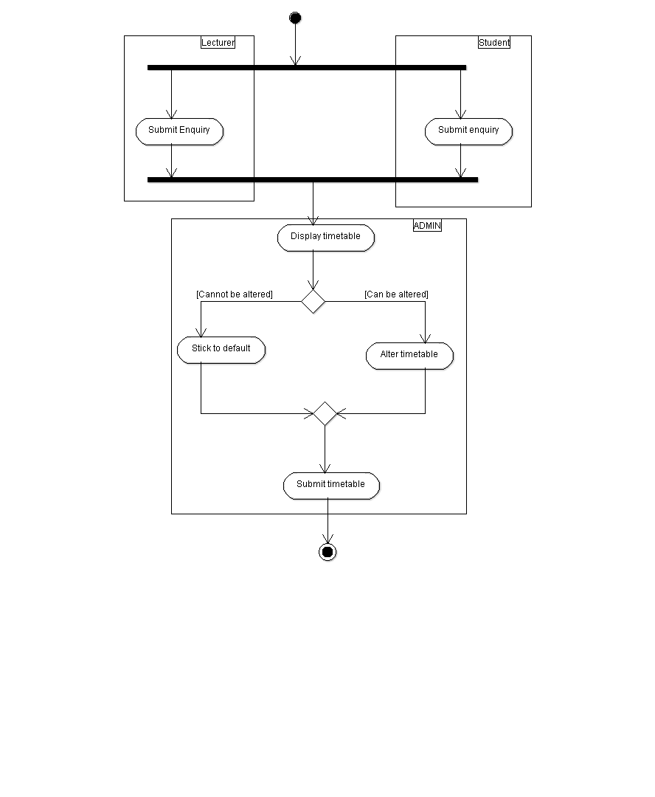Activity diagram 4.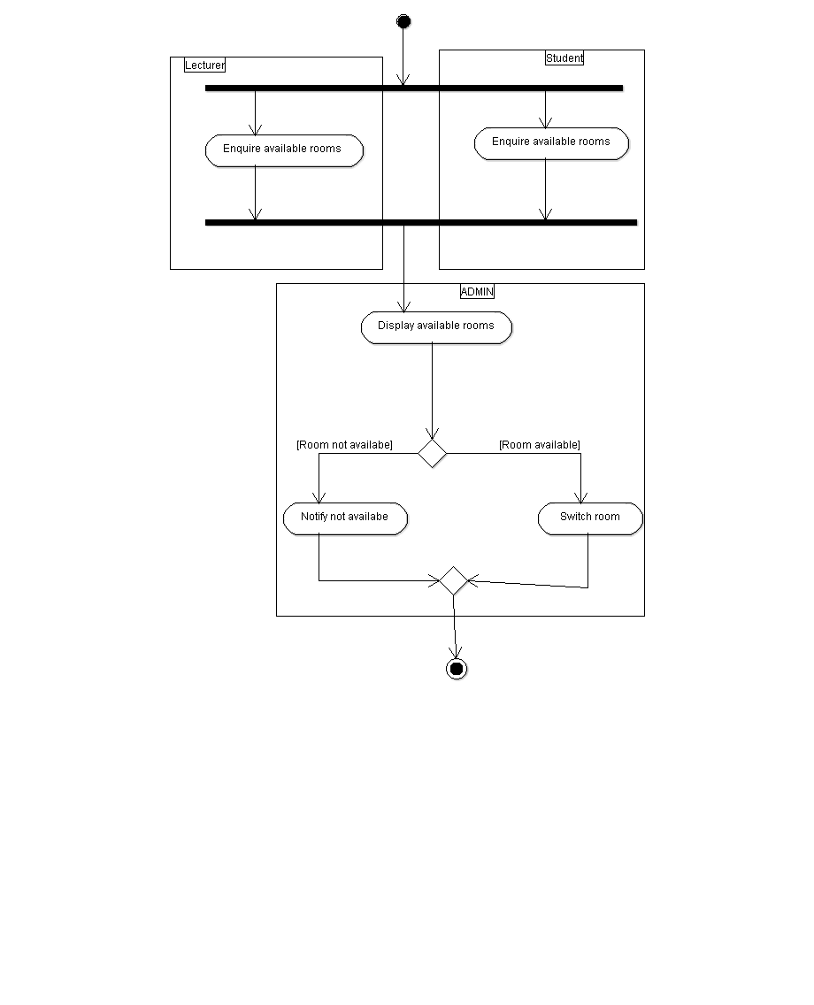

Activity diagram 5.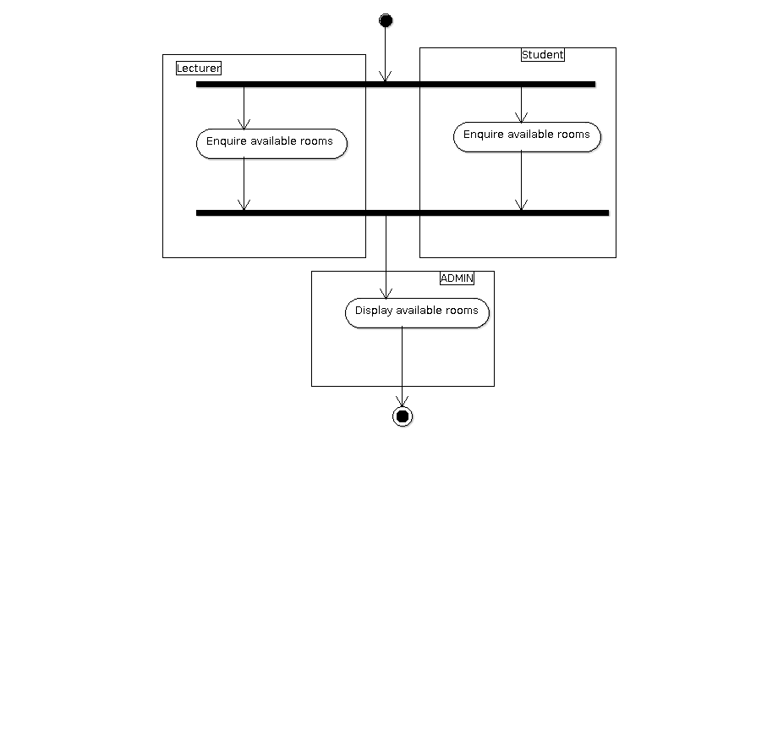Activity diagram 6.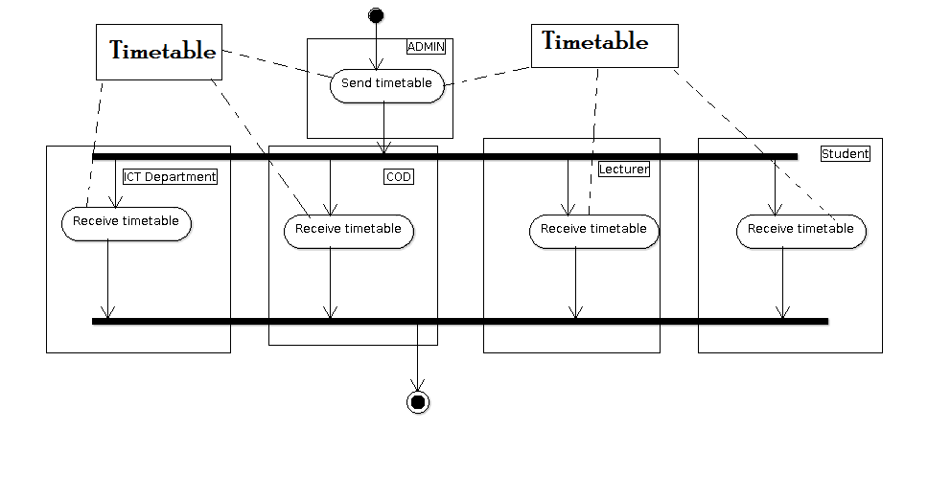

# CRC CARDS

The following were our CRC cards:

CRC Card 1:-CRC Card 3:-

CRC Card 2:-

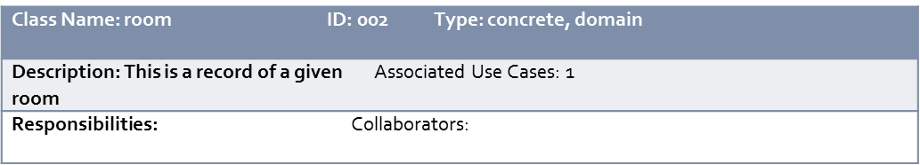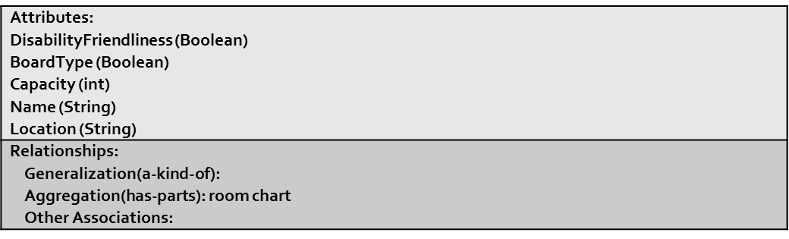

Front:

Back:

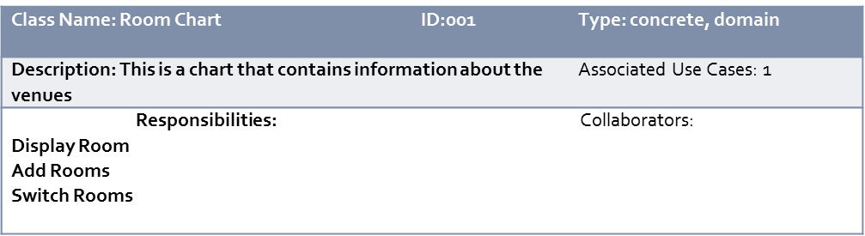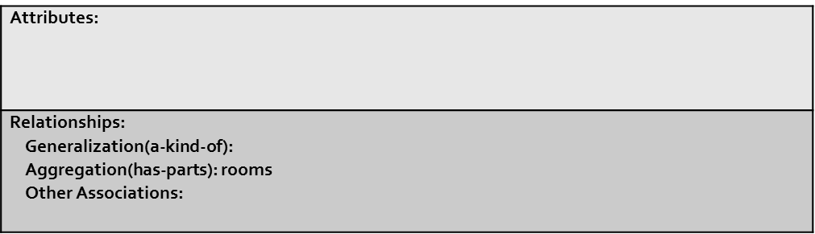

Front:

Back:

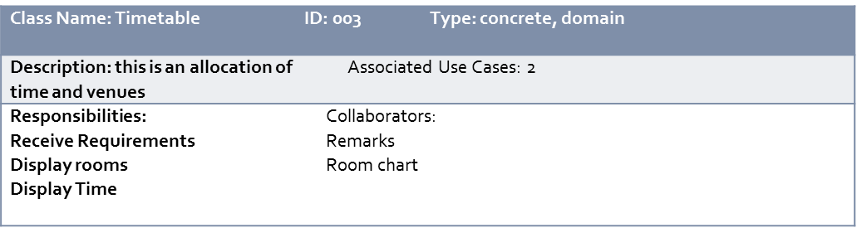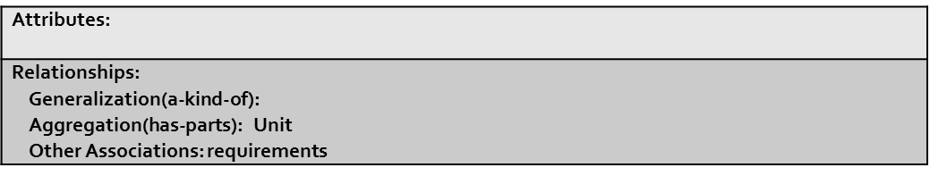

Front:

Back:

CRC Card 4:-

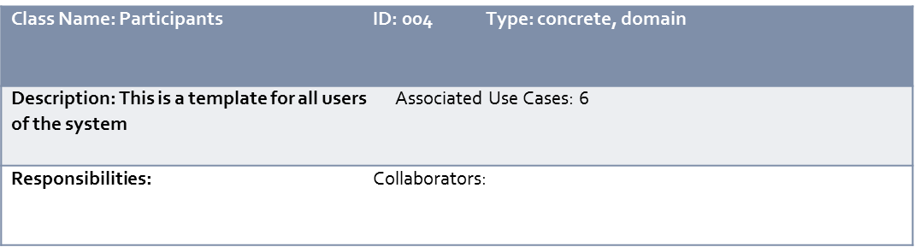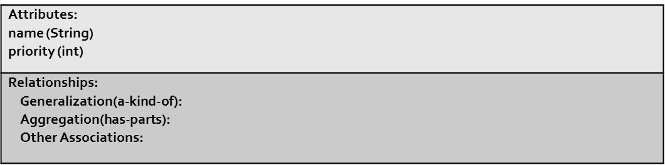

Front:

Back:

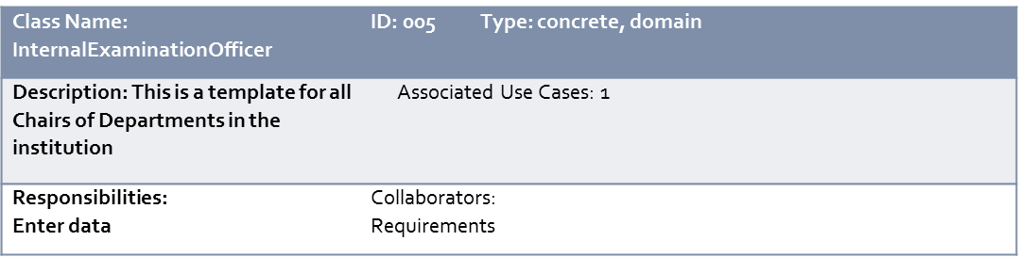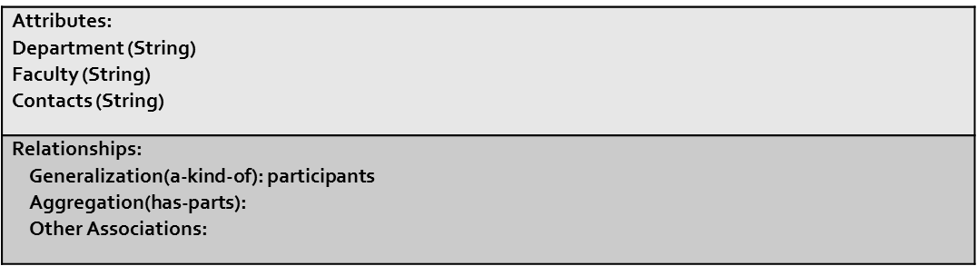

Front:

Back:

CRC Card 6:-

CRC Card 5:-

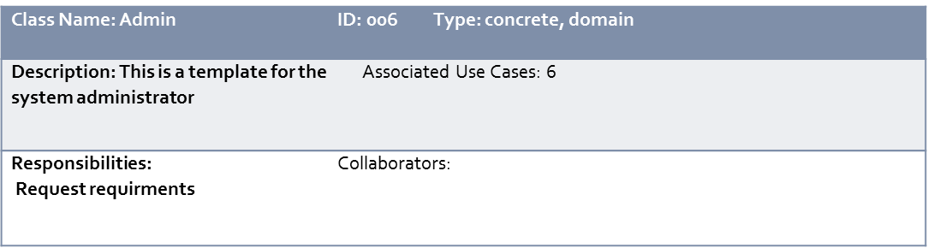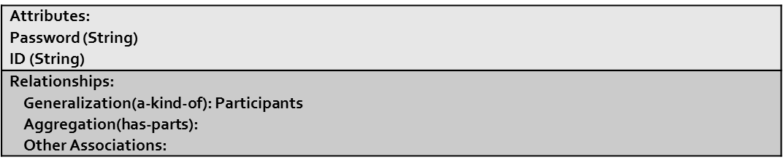

Front:

Back:

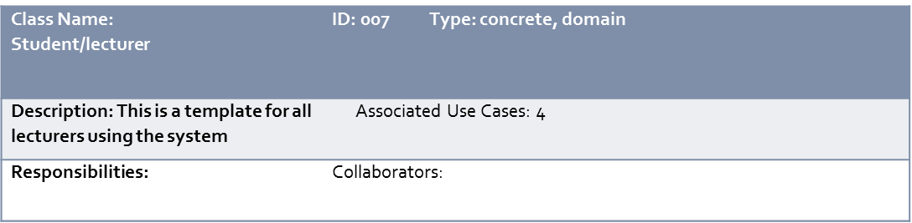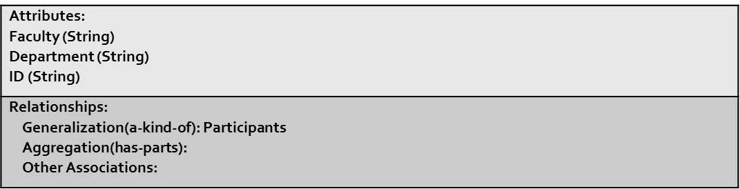

Front:

Back:

CRC Card 7:-

CRC Card 8:-

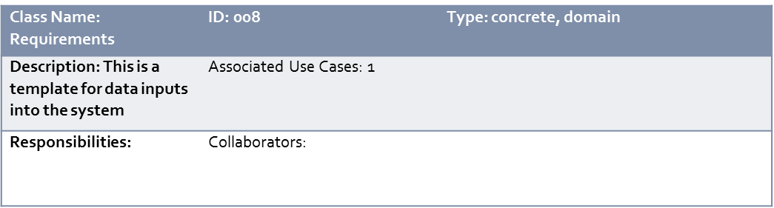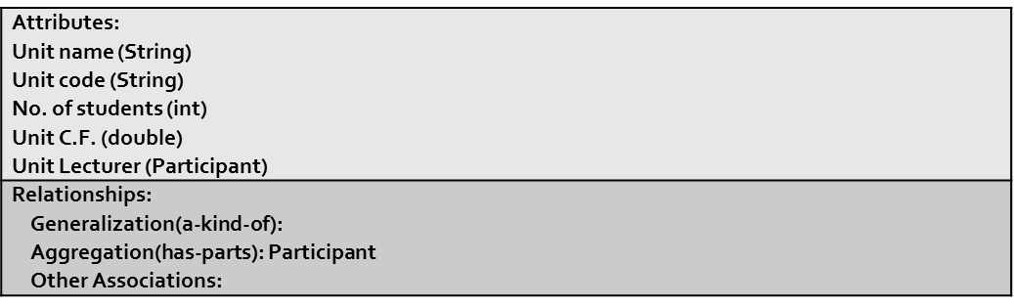

Front:

Back:

CRC Card 9:-

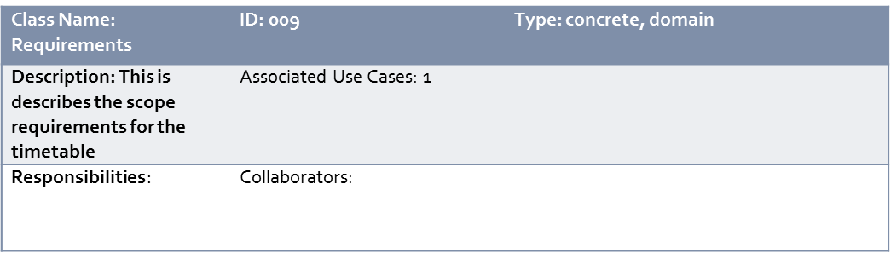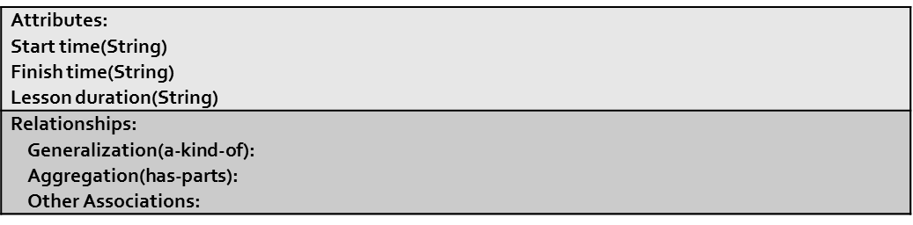

Front:

Back:

# USE CASE DESCRIPTIONS

|  |  |  |
| --- | --- | --- |
| **Use case name**: Enter Data | **ID**: 001 | **Importance Level**: high |
| **Primary Actor**: cod | **Use Case type**: overview, essential | |
| Stakeholders and interests:  Cod – inputs data into the system  Admin – ensures data is received | | |
| **Brief description**: This use case describes how data is entered. | | |
| **Trigger**: time- a month before the semester begins  **Type**: Temporal | | |
| **Relationships**:  **Association**: admin, cod  **Include**:  **Extend**:  **Generalization:** | | |
| **Normal flow of events:**   1. Admin requests data 2. Cod enters data 3. Cod submits data | | |
| **SubFlows:** | | |
| **Alternate Flows:**  2a. The data is incomplete, submission fails. | | |

|  |  |  |
| --- | --- | --- |
| **Use case name:** specify scope | **ID:** 002 | **Importance Level:** medium |
| Primary Actor: admin | **Use Case type:** overview, essential | |
| **Stakeholders:**  Admin – specifies when lessons begin and end | | |
| **Brief description:** this use case describes the time scope of the timetable | | |
| **Trigger**: instructions from school administrations  **Type**: external | | |
| **Relationships:**  **Association:** admin, school administration  **Include:**  **Extend:**  **Generalization:** | | |
| **Normal flow of events:**   1. School administration specifies time scope 2. Admin inputs time scope | | |
| **SubFlows:** | | |
| **Alternate Flows:** N/A | | |

|  |  |  |
| --- | --- | --- |
| **Use case name:** display rooms | **ID:** 003 | **Importance Level:** high |
| **Primary Actor**: admin | **Use Case type:** overview, essential | |
| **Stakeholders:**  Admin – wants to assign the rooms  Lecturers – wants to know of room availability  Students - wants to know of room availability | | |
| **Brief description:** this use case shows the list of available rooms in case of change | | |
| **Trigger**: lecturer/student enquires room availability  **Type:** external | | |
| **Relationships:**  Association: admin, lecturers, students  Include:  Extend:  Generalization: | | |
| **Normal flow of events:**   1. Lecturer/student enquires available rooms 2. Available rooms displayed | | |
| **SubFlows:** | | |
| **Alternate Flows:** N/A | | |

|  |  |  |
| --- | --- | --- |
| **Use case name:** switch venues | **ID:** 004 | **Importance Level:** high |
| **Primary Actor:** admin | **Use Case type:** overview, essential | |
| **Stakeholders:**  Admin – wants to switch the venues as per lecturer/student request  Lecturers – wants to switch the venues on special conditions  Students - wants to switch the venues on special conditions | | |
| **Brief description:** this use case switches one venue with another | | |
| **Trigger:** lecturer/student wants switch venue  **Type:** external | | |
| **Relationships:**  Association: admin, lecturer, student  Include: display rooms  Extend:  Generalization: | | |
| **Normal flow of events:**   1. Lecturer/student asks to switch venue 2. Admin displays available rooms 3. The rooms are switched | | |
| **SubFlows:** | | |
| **Alternate Flows:**  2a. no available rooms found, switch unavailable; go to manual switch(lecturers switch among themselves) | | |

|  |  |  |
| --- | --- | --- |
| **Use case name:** manage timetable | **ID:** 005 | **Importance Level:** medium |
| **Primary Actor:** admin | **Use Case type:** overview, essential | |
| **Stakeholders:**  Admin – wants to search courses, alter and submit timetable  Lecturers – wants to know of course unit time and venue  Students - wants to know of course unit time and venue | | |
| **Brief description:** this use case shows how the timetable is managed | | |
| **Trigger**: lecturer/student submits an enquiry of unit, time and venue  **Type:** external | | |
| **Relationships:**  Association: admin, lecturer, student  Include: display rooms  Extend: switch venue  Generalization: | | |
| **Normal flow of events:**   1. Lecturer/student submits an enquiry of unit, time and venue 2. Admin displays requested information 3. Admin alters timetable as requested 4. Admin submits timetable | | |
| **SubFlows:** | | |
| **Alternate Flows:**  3a. timetable cannot be altered as requested, alteration unavailable; stick to default | | |

|  |  |  |
| --- | --- | --- |
| **Use case name:** deliver timetable | **ID:** 006 | **Importance Level:** high |
| **Primary Actor:** admin | **Use Case type:** overview, essential | |
| **Stakeholders:**  Admin – submits timetable  Ict department – receives timetable  Students – receives timetable  Cod – receives timetable  Lecturers - receives timetable | | |
| **Brief description:** this use case describes how the timetable is delivered | | |
| Trigger: admin submits timetable to necessary personnel  Type: external | | |
| **Relationships:**  Association: admin, ict department, student, cod, lecturer  Include:  Extend:  Generalization: | | |
| **Normal flow of events:**   1. Admin submits timetable. | | |
| **SubFlows:** | | |
| Alternate Flows: N/A | | |

# CLASS DIAGRAM:

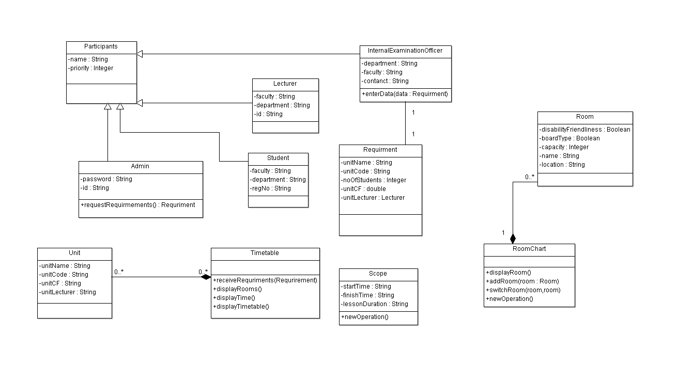

# SEQUENCE DIAGRAMS:

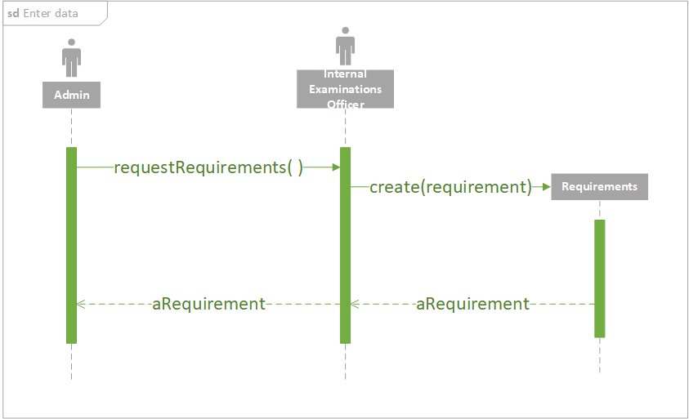

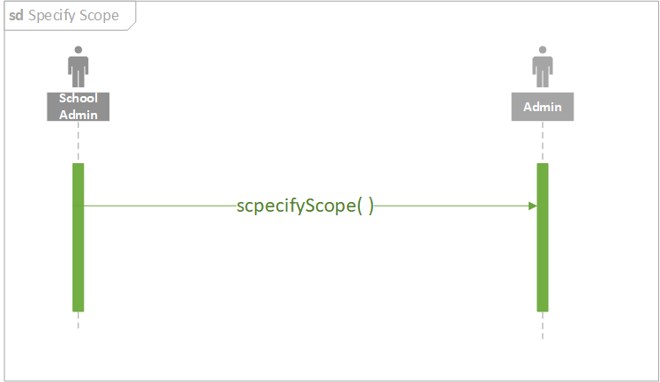

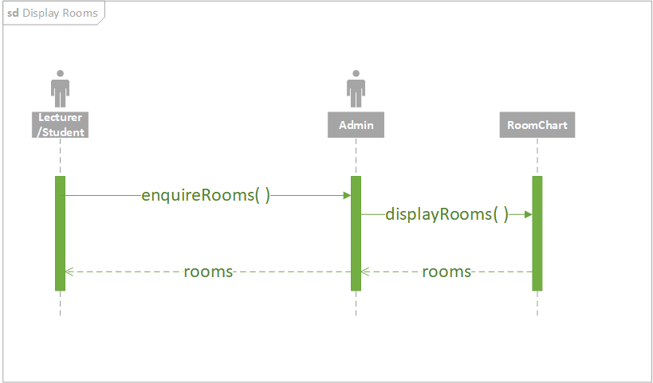

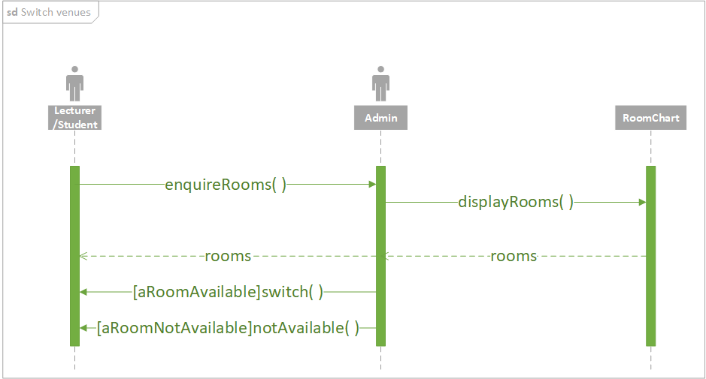

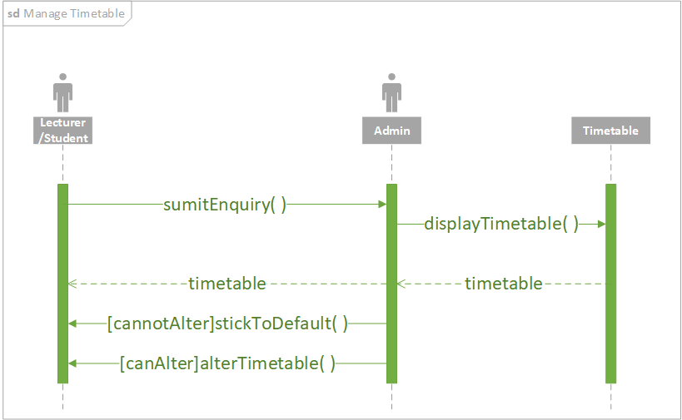

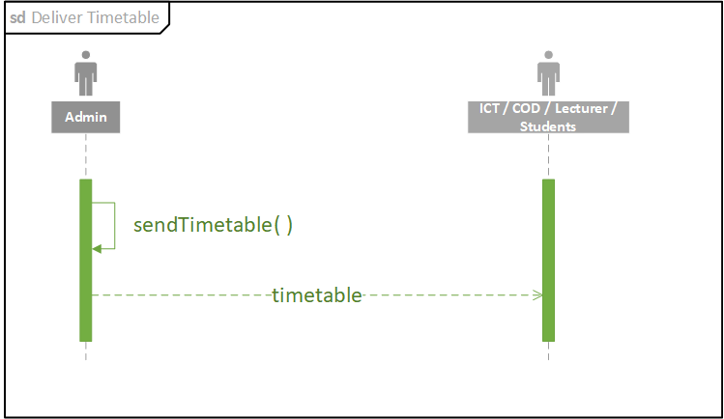

# COMMUNICATION DIAGRAMS:

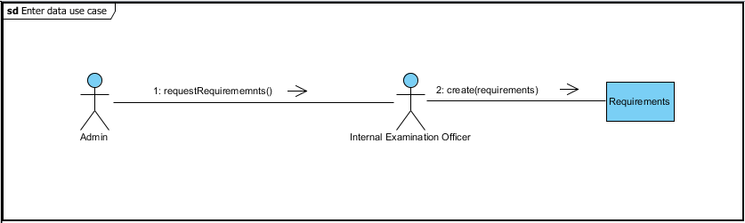

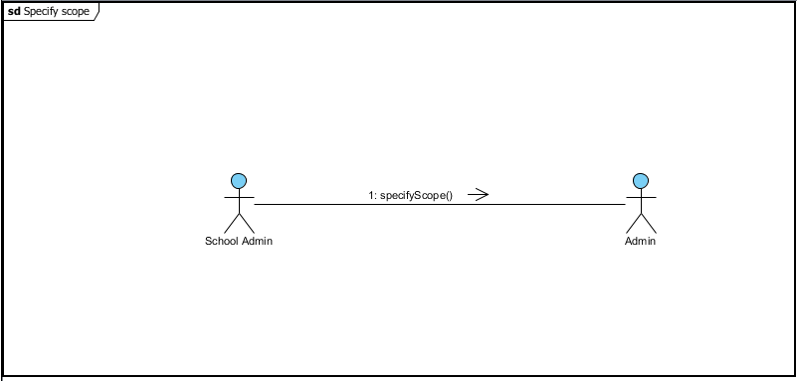

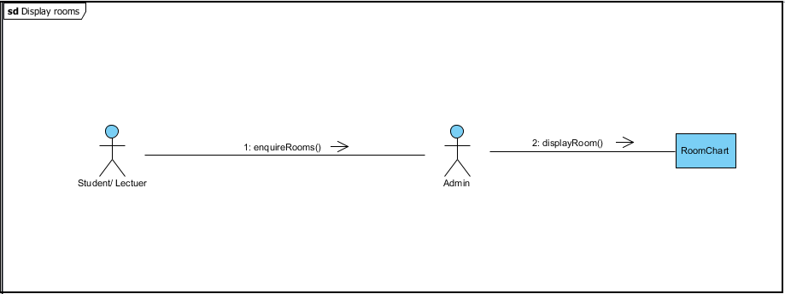

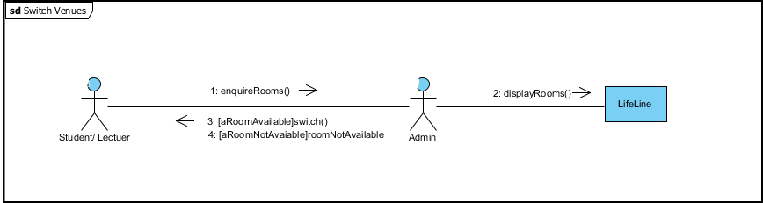

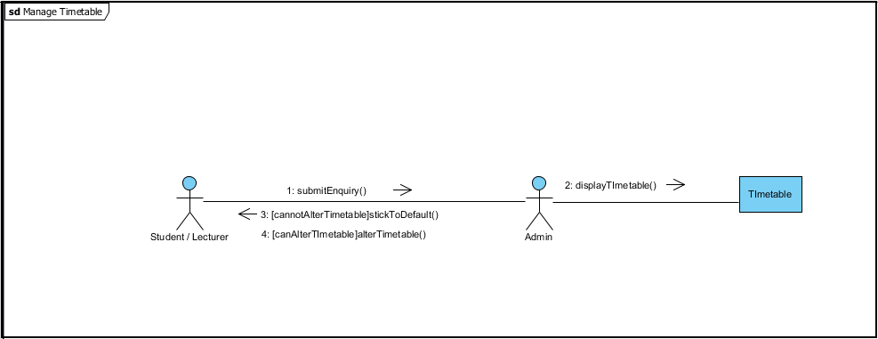

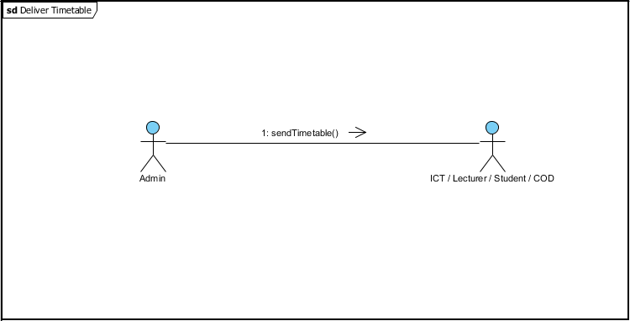

# CRUDE MATRIX:

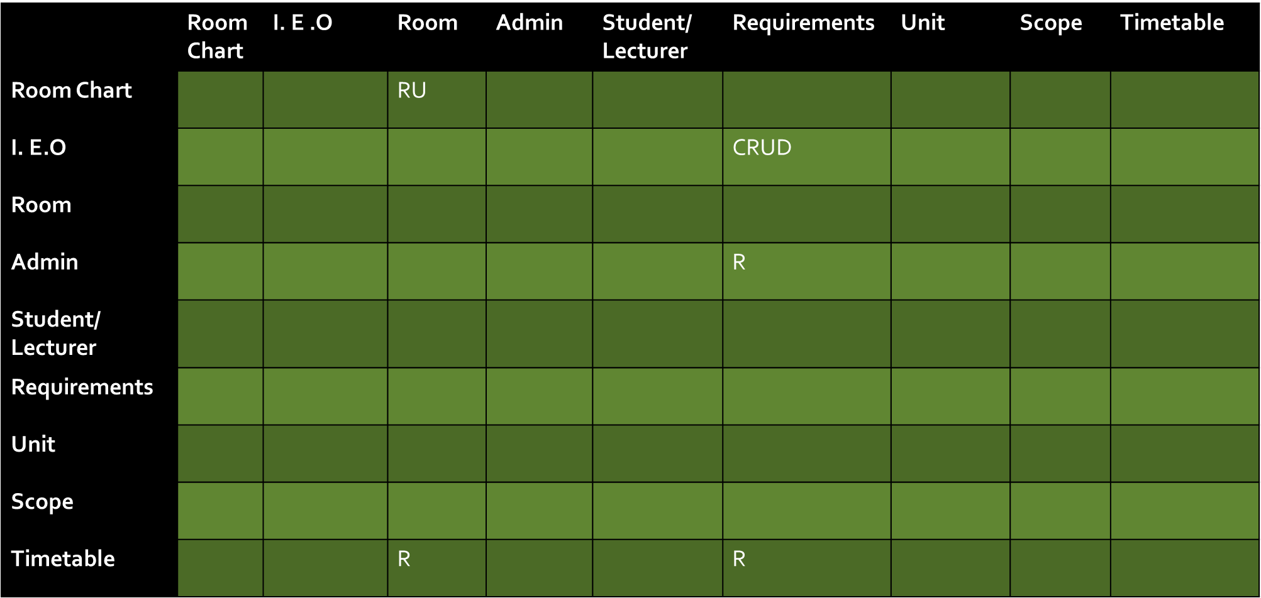

# PACKAGE DIAGRAM:

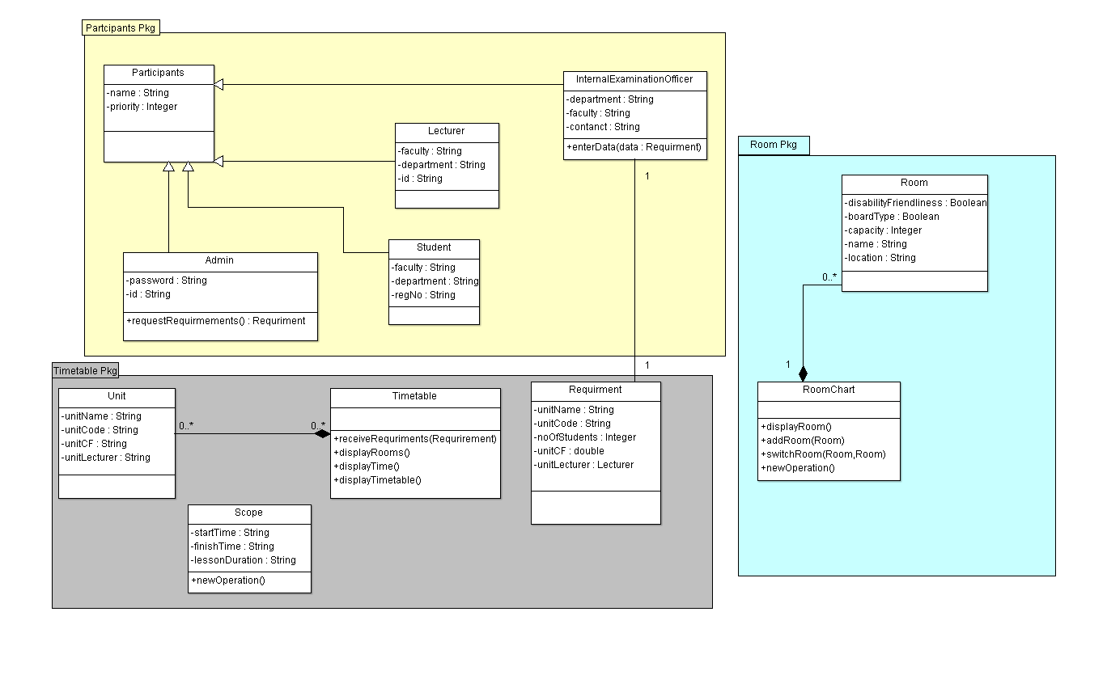

# Method Design

|  |  |  |
| --- | --- | --- |
| **Method name:**  receiveRequirments | **Class Name:** Timetable | **ID:** 001 |
| **Client:** Admin | | |
| **Associated Use Cases:** | | |
| **Description of responsibilities:** implement necessary responsibility to get requirements to the Timetable class attributes. | | |
| **Arguments received:** Requirment | | |
| **Type of value returned:** null | | |
| **Preconditions:** Requirements have been made available by the Internal Examination Officer | | |
| **Postcondition:** | | |

|  |  |  |
| --- | --- | --- |
| **Method name:**  displayTime | **Class Name:** Timetable | **ID:** 002 |
| **Client:** Admin | | |
| **Associated Use Cases:** | | |
| **Description of responsibilities:** this method displays time of lessons | | |
| **Arguments received:** | | |
| **Type of value returned:** null | | |
| **Preconditions:** The timetable is already generated. | | |
| **Postcondition:** | | |

|  |  |  |
| --- | --- | --- |
| **Method name:** displayRooms | **Class Name:** Timetable | **ID:** 003 |
| **Client:** | | |
| **Associated Use Cases:** | | |
| **Description of responsibilities:** implements necessary responsibilities required to display the timetable for any student or faculty member. | | |
| **Arguments received:** | | |
| **Type of value returned:** null | | |
| **Preconditions:** The timetable is already generated. | | |
| **Postcondition:** | | |

|  |  |  |
| --- | --- | --- |
| **Method name:** enterData | **Class Name:** Internal Examination Officer | **ID:** 004 |
| **Client:** | | |
| **Associated Use Cases:** | | |
| **Description of responsibilities:** This method implements functionality required to create and deliver requirements | | |
| **Arguments received:** | | |
| **Type of value returned:** null | | |
| **Preconditions:** The system admin must place a request for data | | |
| **Postcondition:** The data entered must be complete and correct. | | |

|  |  |  |
| --- | --- | --- |
| **Method name:** requestRequiremnts | **Class Name:** Admin | **ID:** 005 |
| **Client:** | | |
| **Associated Use Cases:** | | |
| **Description of responsibilities:** this method is called to notify the IE0 that requirements are needed for the courses offered in his/her department. | | |
| **Arguments received:** | | |
| **Type of value returned:** null | | |
| **Preconditions:** | | |
| **Postcondition:** | | |

|  |  |  |
| --- | --- | --- |
| **Method name:** displayRooms | **Class Name:** RoomChart | **ID:** 006 |
| **Client:** Admin | | |
| **Associated Use Cases:** | | |
| **Description of responsibilities:** this is method is used to display the rooms available in the roomchart | | |
| **Arguments received:** | | |
| **Type of value returned:** null | | |
| **Preconditions:** | | |
| **Postcondition:** | | |

|  |  |  |
| --- | --- | --- |
| **Method name:** addRoom | **Class Name:** RoomChart | **ID:** 007 |
| **Client:** Admin | | |
| **Associated Use Cases:** | | |
| **Description of responsibilities:** this method is used to add a room into the room chart. | | |
| **Arguments received:** Room | | |
| **Type of value returned:** null | | |
| **Preconditions:** The room to be added must exist | | |
| **Postcondition:** There should be at least on extra room in the room chart | | |

|  |  |  |
| --- | --- | --- |
| **Method name:**  switchRooms | **Class Name:** RoomChart | **ID:** 008 |
| **Client:** Admin | | |
| **Associated Use Cases:** | | |
| **Description of responsibilities:** this method is used by the admin to switch rooms if necessary | | |
| **Arguments received:** Room, Room | | |
| **Type of value returned:** null | | |
| **Preconditions:** The rooms must all exist and one should have been allocated. | | |
| **Postcondition:** | | |

# User Interface

We have the Following User Interfaces to request data from users of the system:

1. Enter data is used to request input from the I.E.O.

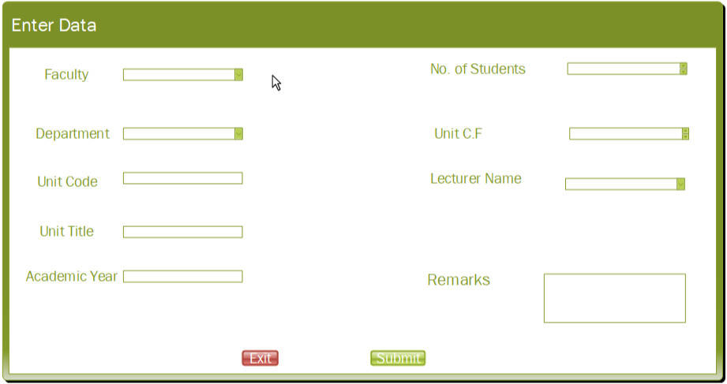

* 1. Switch Venues is used to Switch venues of certain

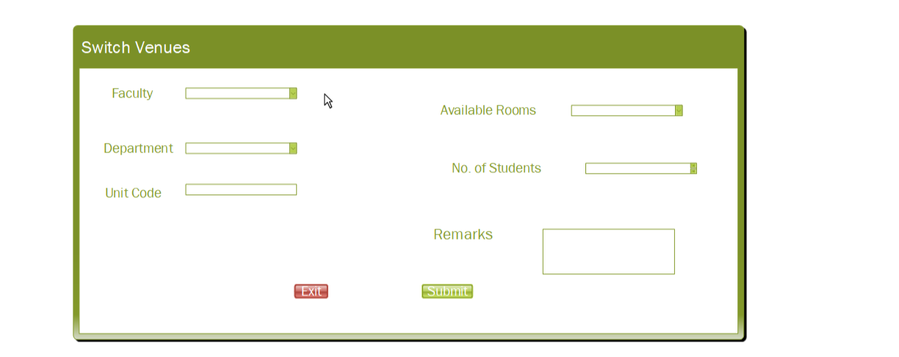

* 1. Admin Login is used to login the administrator to the system

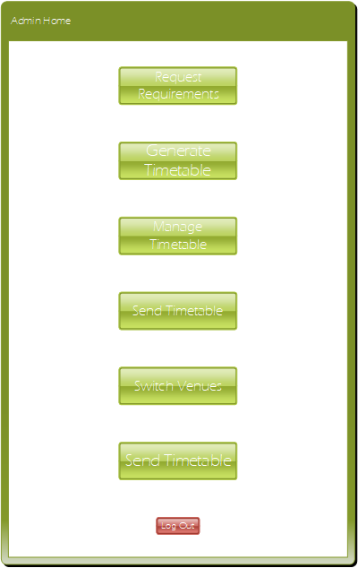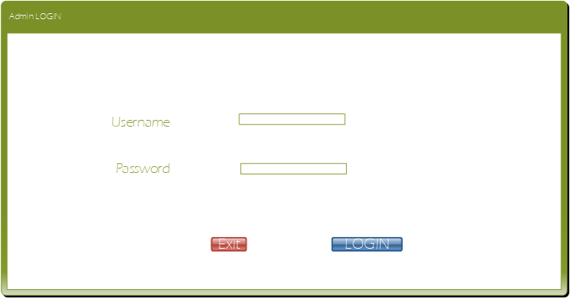d) The Admin Home is used to navigate to various options provided by the system

e) Generate Timetable is a pop-up used to notify the admin that the timetable is made

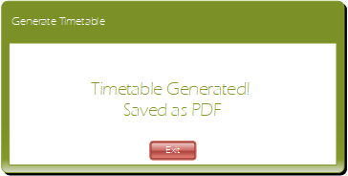

f) Send Timetable is a pop-up used to notify the admin that the timetable is sent

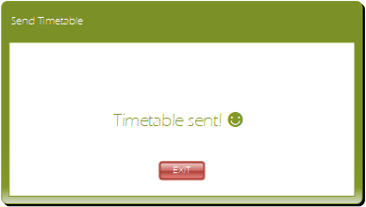

END!